Concrete Compressive Strength: Data-Driven Insights and Recommendations

1. Introduction
In this report, we present our findings from a data analysis aimed at understanding concrete compressive strength, a critical property that determines how durable and safe a structure will be.
Our goal is to provide clear, actionable recommendations based on data-driven insights that can help inform decisions for construction companies and infrastructure agencies seeking to improve mix design efficiency, ensure quality control, and optimize material costs.
Understanding which components most affect compressive strength allows producers to design mixes that meet performance targets while minimizing waste and environmental impact.

2. Key Findings
After analyzing the dataset of over 1,000 concrete mix samples using gradient descent optimization and multivariate regression, several consistent patterns emerged:
Cement content, slag content, water, and curing age are the most influential predictors of strength.
Higher cement and slag proportions increase strength, while excess water consistently decreases it.
Superplasticizer contributes positively by improving workability without weakening the mix, though its impact plateaus at higher levels.
Aggregates and fly ash have minimal direct linear influence, suggesting their effects are more complex or interaction-based.
Applying a log transformation to predictor variables improved predictive accuracy dramatically (Train R² = 0.80, Test R² = 0.76), showing that nonlinear relationships exist between mix components and strength.

3. Recommendations

Recommendation 1: Control the Water-to-Binder Ratio
Keep the water-to-binder ratio as low as feasible without sacrificing workability.
Use moisture-adjustment sensors or automated batching to monitor total water input in real time.
Reducing water content by even small amounts can substantially improve strength and reduce variability.

Recommendation 2: Replace Excess Water with Superplasticizer
The data show that superplasticizer increases strength up to a point by improving workability without weakening the cement matrix.
Substituting part of the mixing water with superplasticizer helps achieve desired slump while maintaining structural performance.

Recommendation 3: Incorporate Slag as a Supplementary Binder
Slag demonstrated a strong positive effect on compressive strength.
A partial replacement of cement with slag can both increase long-term strength and reduce CO₂ emissions associated with cement production.

Plots and Tables
Model Performance Table
This table compares the training and testing performance of three models: one using raw predictors, one with standardized predictors, and one using log-transformed predictors. The log-transformed model achieved the lowest Mean Squared Error (MSE ≈ 55 on train / 54 on test) and the highest R² (≈ 0.80 train / 0.76 test), showing that the logarithmic transformation of input variables provides the best generalization and captures nonlinear relationships in the data.
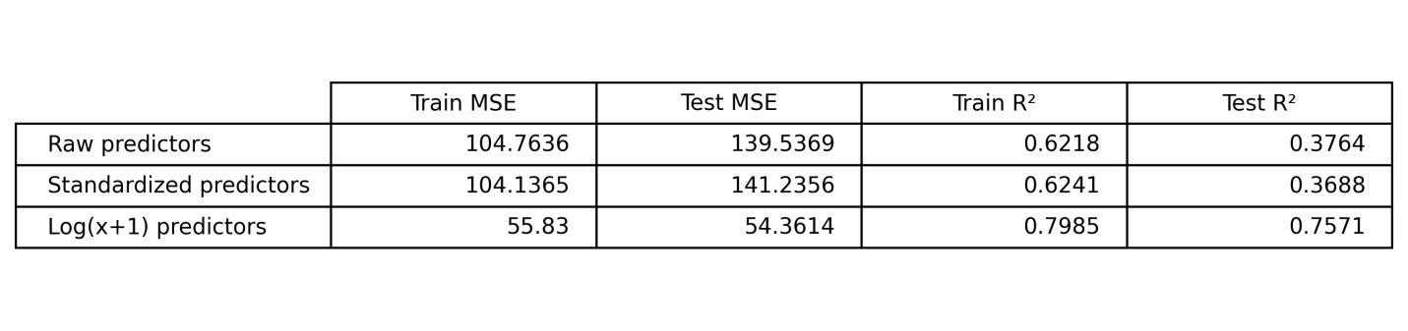
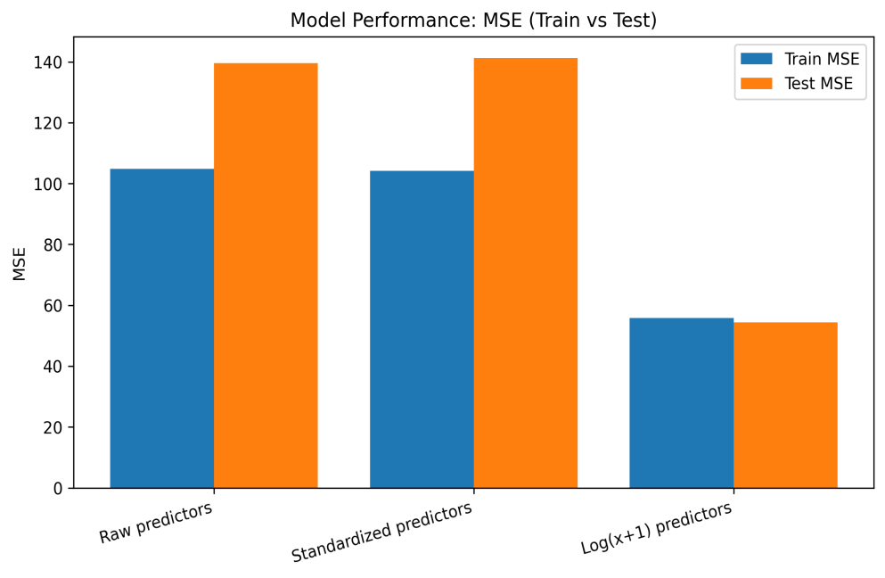
MSE Bar Chart
The bar chart visually compares the Mean Squared Error (MSE) for each model on both training and testing data. The first two models (raw and standardized) show high MSE values (~100–140), indicating poorer predictive accuracy. In contrast, the log(x + 1) model shows much lower MSE values on both datasets, confirming its superior performance.

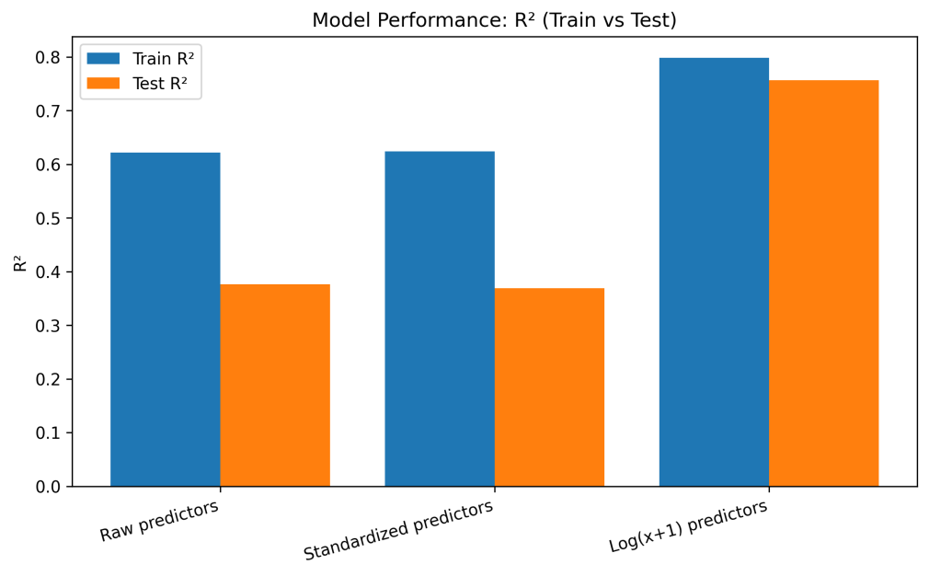
R² Bar Chart
This plot shows the coefficient of determination (R²) for each model, representing how much variance in concrete strength is explained by the predictors. The log-transformed model explains almost 80% of the variance in training and over 75% in testing data, far outperforming the other two models, which only explain around 36–62%.

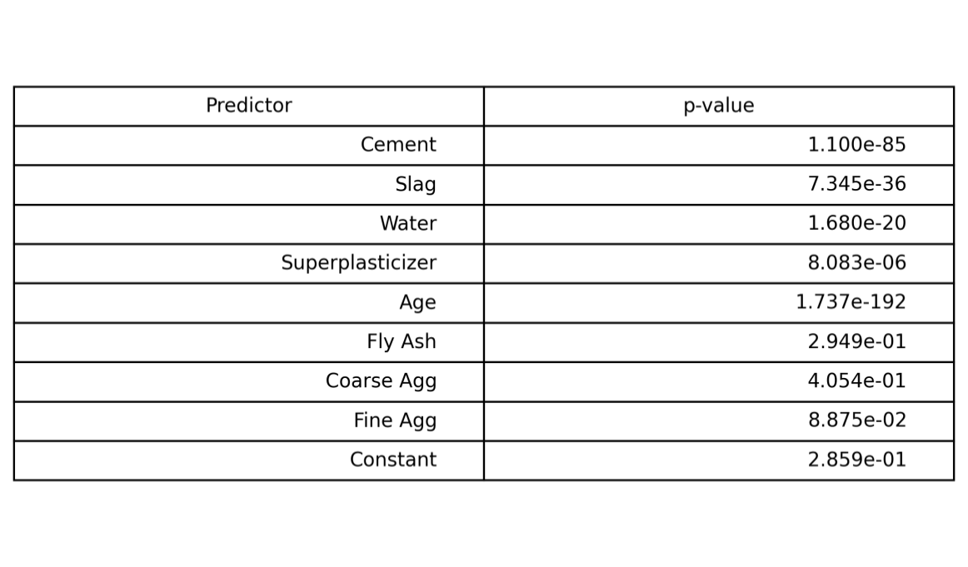
P-Values Table (Log-Transformed Model)
This table lists the statistical significance of each predictor variable. Cement, slag, water, superplasticizer, and age all have very small p-values (≪ 0.05), meaning they are statistically significant in predicting compressive strength. Fly Ash, Coarse Aggregate, and Fine Aggregate have higher p-values, suggesting their effects are not significant in this linear model.

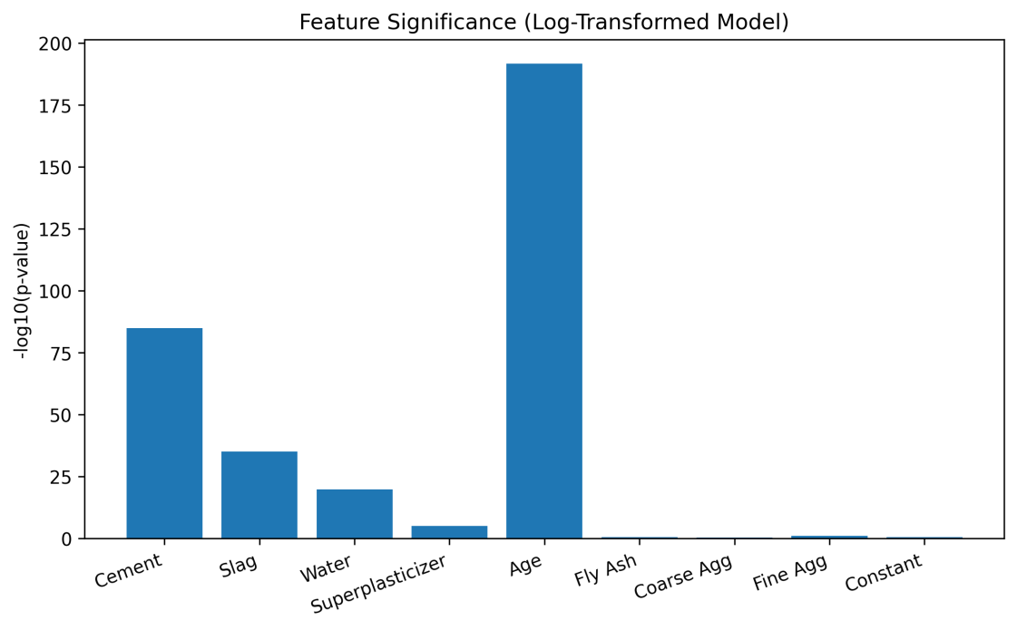
Feature Significance Bar Chart (-log₁₀ p-Values)
This chart visualizes predictor significance on a logarithmic scale. Taller bars represent more statistically significant features. Age and Cement are by far the most influential variables, followed by Slag and Water. The small bars for aggregates and Fly Ash confirm their limited predictive importance.

4. Benefits
Implementing these recommendations will provide measurable business and operational gains:
Higher quality and durability: Stronger concrete reduces maintenance and extends service life.
Material cost efficiency: Optimizing binder and water ratios can lower cement consumption.
Sustainability: Greater use of slag reduces carbon emissions.
Process reliability: Data-driven QC leads to fewer rejected batches and less waste.
Regulatory compliance: Improved consistency ensures strength specifications are met or exceeded.

5. Conclusion and Next Steps
This analysis demonstrates that concrete compressive strength can be accurately predicted and optimized using data-driven techniques.
The findings highlight water control, binder composition, and curing age as the dominant factors affecting performance.

Next Steps
Pilot implementation: Apply the predictive model to one production line and monitor results for 4–6 weeks.
Integrate QC monitoring: Track predicted vs. actual strength in daily quality logs to verify model accuracy.
Expand modeling: Explore nonlinear interactions (e.g., Fly Ash × Age) and develop automated mix-optimization dashboards.

